New Era Software 

Business Plan

Prepared by:

Kiaan Moodley

2202459

Dinolan Naidoo

1842861

Ashley Jurisich

1946550

**Executive Summary**

The business is named New Era Software (NES), and is comprised of three core members. These are Kiaan Moodley, Ashley Jurisich and Dinolan Naidoo. They are all students at the University of the Witwatersrand and are all currently pursuing an engineering degree in Digital Arts.

NES is a start-up company in the University of the Witwatersrand, that is planning to launch an online website that assists users in understanding and calculating how much energy is consumed by their transport vehicles, as well as comparing it to a vehicle that uses electric energy. This will be done by having the user insert the required information, such as the type of energy source, fuel economy (L/100 km) and the distance travelled. All this information is used to calculate the amount of energy consumed; liters of energy consumed, as well as the total amount of money spent on this energy. It will then also show how much energy will be consumed travelling the same distance using a transport vehicle that uses electric energy and the price of that energy. The comparison is made using bar graphs. This sort of website is primarily targeted at businesses who largely depend on the use of transport vehicles. The secondary target group is focused on people who are looking for another, environmentally friendlier, energy source, other than petrol and diesel. This website pushes them towards the idea of using transport vehicles that make use of electrical energy. The online site project is intended to make profit through subscriptions. This will increase income revenue. Users may use the demo version for a once-off comparison, whilst the subscription service will store their previous data comparisons. With a mixture of a strong work force, and professional practice in development, this site will be beneficial to everybody who makes use of it, building a strong reputation for the company.

**Mission**

The people at NES want for nothing other than providing people with information that support cleaner energy alternatives. With thorough research, meticulous analysis and reliable calculations, the business will certainly lead people to a future with purer environmental practices.

**Keys To Success**

We, at NES, have identified important elements that we strive to stick to, in order to build a successful business.

* Consider the economic consequences of using such energy
* Provide the most optimal solutions that benefit both the user and the environment
* Ensure user interface is operative and effective

**Objectives**

The business has picked out several points to look out for to keep an eye on to determine the long-term success of the business.

* The solutions provided become standard practice in businesses
* Decrease in the demand for petrol and diesel
* Long time subscription periods from users

**Company Summary**

This business is a start-up company based in the University of the Witwatersrand. This business intends to create a website that anybody can use, however is primarily focused towards large businesses. It allows users to compare their own transport energy usage, to what it would be like if electric energy was being consumed instead.

**Technologies to be used**

The most crucial element required for the project is client-side technologies, such as HTML, CSS and JavaScript. HTML is a language that makes up the content of the website and tells the browser what to show on the website. CSS is a language used to describe the presentation of the website. JavaScript is a programming language commonly used to create interactive effects within web browsers. The remaining technology elements that make up a website are server-side, meaning that they reside and operate on the server. In order to program business logic or custom functionality on the website, web developers use programming languages. The development team will make use of the IDE Visual Studio. Node.js is also being used, this is the back-end JavaScript runtime environment that executes the code outside a web browser. A database engine or database server is the underlying component of the website where the entire website’s data is stored. MSSQL was chosen by the development team to be the database engine as it is one of the easier ones for beginners to get a grasp on, with the aid of SQL Management studio which is a software application that is used for managing and configuring all components within MSSQL server. The website will be deployed using Cloudflare, as this is a free-to-use application.

**Start-Up Summary**

These are what is needed for the business to begin operation:

* Computer system including three workstations
* Internet access (12 months minimum)
* Assorted software that can support multiple coding languages, such as Java, CSS and HTML.
* Microsoft Office
* Miscellaneous Office Supplies (desks, chairs, etc.)

|  |  |
| --- | --- |
| **Assets** | **Costs (R)** |
| Computer Systems and Workstations | 9399 x 3 = 28197.00 |
| Internet Access | 516 x 12= 7224.00 |
| Microsoft Office | 999 x 3 = 2997.00 |
| Miscellaneous | 8650.00 |
| **Total** | **46036.00** |

|  |  |
| --- | --- |
| **Liabilities** | **Costs (R)** |
| Currently Borrowing | 0.00 |
| Long-term Liabilities | 0.00 |
| Outstanding Bills | 0.00 |
| **Total** | **0.00** |

**Company Ownership**

NES is a company whose ownership is shared between three people, Kiaan Moodley, Dinolan Naidoo and Ashley Jurisich.

**Services**

New Era Software offers an alternate solution to the energy consumed by transport vehicles. The website intends to compare the energy consumed by vehicles that are powered by either petrol or diesel, with electric powered vehicles, in an attempt to try and convince the users to switch over to the more environmentally friendly electric energy. Users enter the required details into the website, and the website will then calculate the energy consumed by the vehicle. The calculated answer is then compared to an electric vehicle with the same distance and fuel economy that the user previously entered as the variables of the calculation. The user will then be able to see how little energy an electric vehicle consumes compared to vehicle they are currently using. Users will also be allowed to sign up to the site, which also allows for a backlog of information to be stored, this enables users to check their history to view previous comparisons. Users will only be allowed access to the database if they are paying subscriptions. User may still be able to use a free version of the calculator for a once-off calculation and comparison for up to 4 different inputs.

**Proposed Testing and Quality Assurance**

NES has identified several ways to test the operations of the website. These are:

* Functionality Testing
* Ensures that each function of the website operates in conformance with the requirement specification. Functionality testing is done to ensure the system works as required, including the user interface.
* Database Query Testing
* Unit Testing
* Verifies the calculations made by the webpage are accurate.
* Performance Testing
* Aims to determine how a system performs in terms of responsiveness and stability under a certain load. Site has to withstand a substantially large load.

**Market Analysis Summary**

The primary target audience is businesses that make use of transport vehicles which consume either petrol or diesel. NES aims to convince the users to switch to an environmentally cleaner source of energy for transport vehicles. The secondary target is everyday individuals that use either private or public transport to get from one place to another. There is no direct opposition in the electric energy industry, as there are no businesses that provide a similar service. The industry aims to promote the use of alternative sources of energy for transport vehicles through the use of a website. NES decided to make this project a web service because it can be accessed on any device with internet connection.

**Market Segmentation**

The primary target group are large businesses that require transport vehicles. If they were to be made aware of the consequences of using either petrol or diesel for their transportation requirements, and also the benefits of electrical energy, they may decide to change. This will make up a large portion of the electrical vehicle market. The secondary target group is made up of individuals and small businesses who regularly make use of either public, private or parastatal transport. The individuals would definitely be interested in the service provided by the business as it is beneficial to them. The individuals age would not necessarily be a factor for the target audience; however, we expect citizens who are for familiar with technology to be more accustomed with how the website operates. More attention will be paid to the secondary target group once the infrastructure to support electric vehicles become common across South Africa.

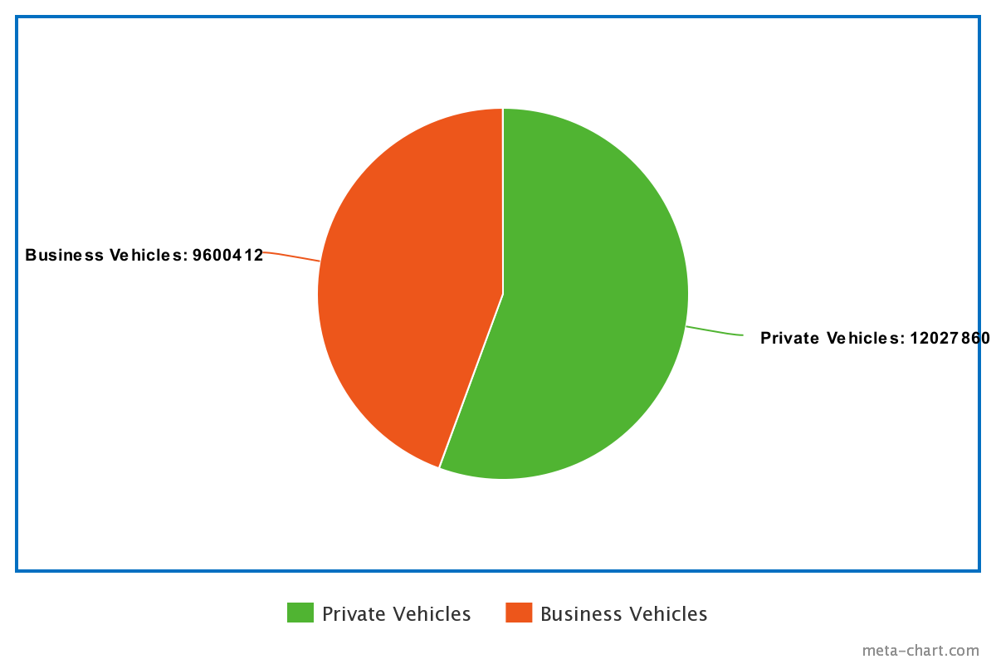Market Analysis showing number of privately owned vehicles vs business owned vehicles on South African roads as of 2018

**Target Market Segment Strategy**

NES has chosen these two market segments for certain reasons. The market in South Africa is not large for electric powered vehicles; however, the market for petrol and diesel is becoming more unstable. With the prices of these energy sources rising, businesses and individuals will certainly be looking for alternatives. This is why the business sector is targeted primarily, and why it is more crucial to introduce them to an alternative energy source. By not only marketing electrical energy as cheaper, but also as greener energy source, businesses will feel encouraged into incorporating electric powered vehicles for transportation. By businesses also increasing the number of electric vehicles in South Africa, it will also broaden the market for individual private vehicle owners. This will result in the vehicle market being flooded with an import of electric vehicles, and eventually encourage the manufacture of charging ports in all garages across South Africa. The individual users will make use of the website so that they may compare the energy that they consume for transportation purposes, with what energy will be consumed if they used a vehicle that is powered by electric energy.

**Service Business Analysis**

The practicing of cleaner environmental practices is an industry that is growing at an increasing rate. It has recently seen the emergence of several large scaled projects launched across South Africa. This is due to recent global political and economic issues that have recently risen. For years, the only benefit to cleaner energy sources, were those of environmental interests, now however; there is more to it, growing the industry.

**Competition and Buying Patterns**

There is no direct competition, instead it comes in another form. That being the energy sources that currently make up the largest part of the industry, diesel and petrol. Consumers may be unaware of the benefits that are brought about by using electrical energy to power transportation vehicles and decide to stick with petrol and diesel. It may also be an issue for large transport vehicles, such as trucks and trains, to suddenly be switched out for newer models, that consume much less energy. This will require large investments and a bit of time to fully introduce South African transport roads and rails to electric vehicles. Garages will also have to renovate their current stations to include charging ports for electrically powered vehicles. It can be seen that it would require a large-scale initiative, with co-operation from all involved parties for these vehicles to be fully embraced in the transport industry. With such an empty market available, the sooner businesses and individuals decide to make the change, they would reap the benefits almost immediately.

**Strategy and Implementation Summary**

New Era Software’s business strategy will leverage the fact that the people are unaware of how much electric transport can benefit individuals and businesses. Once businesses learn of how efficient it is to use electric vehicles, they may inflate the market with these vehicles to increase their own company profits. Businesses will be relied upon as the voice of public appeal for government to get involved and build infrastructure and stations that can support electric transport vehicles. Electric powered vehicles will massively improve the economic and environmental state of the country in the long run, even if the electricity has to be bought from another country that produces electricity from a renewable source.

**Competitive Edge**

NES will use its competitive edge of economic and environmental justification to turn individuals and businesses into website users. The business will use this website service as the main artillery in attempting to convince its users that electric energy is the future of transport vehicles. This industry will grow hand in hand with renewable energy. As the likes of solar, nuclear and hydroelectric energy become more prevalent globally, the use of electric powered vehicles will soon begin taking over. The vehicle revolution has already begun in large, first world countries, it is only a matter of time before it gains traction in South Africa.

**Marketing Strategy**

Very little marketing will be needed. NES believes that with the recent growth of renewable energy as a source for electricity, people will start looking at how else this energy can be implemented. NES plans to directly contact large businesses and offer this service to them exclusively. Once the business grows to a comfortable point where it is able to support millions individual and small businesses, social media will be used as a method to introduce the NES name to households. Advertisements will primarily focus on social media as this is the most used and talked about media medium.

**Sales Strategy and Forecast**

The sales strategy takes into account the philosophy and reasons why many of the people are attracted to electric powered vehicles is because of their environmental ethics. The sales strategy will make use of this desire, alongside the fact that environmental decisions can have positive economic impacts in the long term. Therefore, the sales strategy will pressure the competitive edge of economic justification as the method for turning sales leads into users of the website. For this strategy to be effective, the population of electric vehicles on South African roads will have to increase. NES has adopted a conservative sales forecast for the business plan. By adopting a conservative prediction, it is easier to hit sales goals and increase the likelihood that the business plan is relevant to the business. The business aims to use the website to create steady streams of revenue, and also to create awareness for a situation, as well as provide a solution.

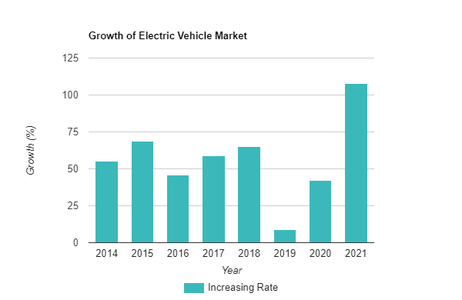

Graph depicting the global increase in the growth rate of electric vehicles as of 2021

As can be seen from the above graph, there will most definitely come a time when electric vehicles take over global roads, including South African. This project serves as a catalyst, and can help people and businesses prepare for such a future. As the electric vehicle market increases exponentially, it will result in no shortage of website users.

**Milestones**

NES has identified several milestones that identify the route to success. Performance will certainly increase through the quest of achieving each goal. These milestones are:

|  |  |
| --- | --- |
| **Milestone** | **Date Completed By** |
| Proposal | 09 – 05 - 2022 |
| Status report | 24 – 05 - 2022 |
| Status report | 31 – 05 - 2022 |
| Final Submission | 10 – 06 - 2022 |
| Presentation | 13 – 06 - 2022 |
| Full Deployment | 01 – 05 - 2023 |

**Web Plan Summary**

The website is the primary service this business provides. It will take in the user’s input data- and show how much energy their non-electrical vehicle consumes- and compare it to how much energy an electric vehicle will consume- using the user’s same input data.

**Website Marketing Summary**

The plan for marketing the site is fairly simple; submission to search engines such as Google and listing the website on all of the company’s social media.

**Development Requirements**

This project will use local website developers to build the site.

**Management Summary**

NES is led by the development team. All three members of the team are students at the University of the Witwatersrand. The group dynamics is democratic, there is no single person in charge. This is the first project that the development team will be taking on. The project management methodology the development team chose is agile,which isthe continuous incremental improvement through small and frequent testing. The team does have some history of creating and managing websites. The business model for this company is to make assessments on how electrical energy has greater economic and environmental benefits than other energy sources, in regards to transportation. The team meet up regularly at the University of the Witwatersrand to give each other updates on the progression of the project. They also have regular online meetings, using Microsoft teams. The workload is split up between the team members, each individual is responsible for their own parts of the project. They do collaborate when it is required, and also help each other to meet deadlines.

**Personal Plan**

A prototype will be launched eleven months before full deployment of the actual site. The date of the site launch is scheduled for May 1, 2023, therefore leaving the prototype date to be June 10, 2022. The development team will work together, sharing responsibilities, in order to meet these deadlines.

**Budgetary Considerations**

|  |  |  |
| --- | --- | --- |
| **Name** | **Starting Salary (R/month)** | **Potential Salary after 1 year (R/month)** |
| Kiaan Moodley | 20 000 | 24 000 |
| Dinolan Naidoo | 20 000 | 24 000 |
| Ashley Jurisich | 20 000 | 24 000 |
| **Total** | 60 000 | 72 000 |

As inexperienced software developers, a typical salary starts between R14 000 and R24 000 per month. We have included quarterly raises usually received during the first year of work to determine an average monthly salary. After a year of work, the monthly salary increases due to the amount of experience employees have gained. The salary received by employees will continue to increase further in the future to account for experience levels and inflation.

Since NES will be launching their website with Cloudflare, the business will have to pay for hosting service fees. That amount comes out to a total of R37 389.12 a year.